New Progress in the Research of Flexible Oxide Transistors Made by Key Laboratory of Polar Materials and Devices, Ministry of Education
Recently, the research group led by Prof. Ping-Hua Xiang of the Key Laboratory of Polar Materials and Devices, Ministry of Education, has made important progress in the research of flexible oxide transistors. This research is the first to develop a fully transparent flexible WO₃ transistor, which reveals the physical mechanism of metal-insulator phase transition induced by electronically controlled hydrogenation, and has made new breakthroughs in flexible electronics and electronically controlled hydrogenation dynamics. The research result is titled "Hydrogenation Dynamics of Electrically Controlled Metal-Insulator Transition in Proton-Gated Transparent and Flexible WO₃ Transistors" on August 22 in the international journal "Advanced Functional Materials" (IF: 15.6). The first author of the article was Dong-Dong Xu, a doctoral student of ECNU.
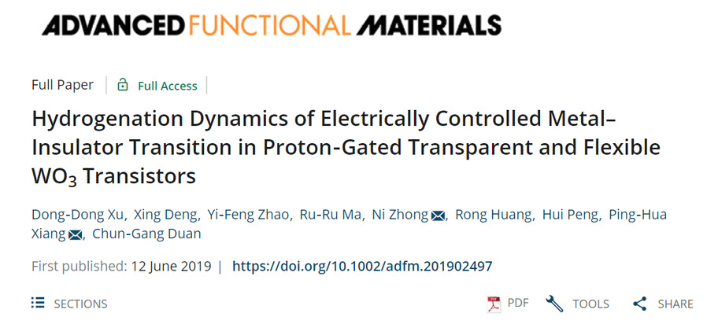
With the rapid development of flexible electronic technology, the research of flexible oxide thin films has received extensive attention. However, conventional flexible PET, chitosan and other organic substrates cannot withstand the temperature of oxide crystallization (usually T > 600 ℃), making it difficult to obtain flexible films with good electrical properties. The mica flakes featuring natural atomically flat (001) cleavage plane, high chemical inertness and thermal stability (~ 1000 ℃), high light transmittance and good mechanical flexibility, can be used for the epitaxial growth of various oxide films. It provides a new way for low-cost manufacturing and high-temperature applications of high-performance flexible electronic devices.
Based on this idea, we achieved the high-quality growth of WO₃ thin films on natural mica substrates using van der Waals epitaxial technology. At the same time, a fully transparent flexible field effect transistor was prepared successfully with a new kind of free-standing ionic gel as gate dielectric. Based on the prototype device, Xiang’s group observed the two metastable phases of hydrogenated WO₃ and their phase separation processes for the first time, and realized a highly controllable metal-insulator phase transition in WO₃ thin film. Through the cooperation with Prof. Chun-Gang Duan's team, the micro-kinetic process of the phase transition was revealed by first-principles calculations, which provides guidelines for the design and development of metal-insulator transition-based devices.
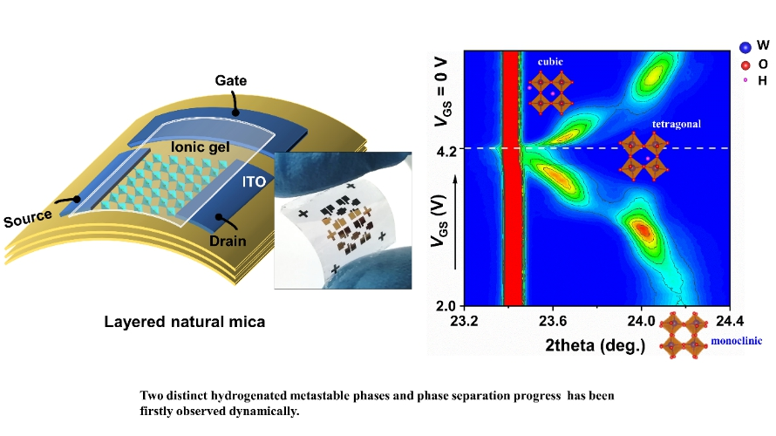
Schematic diagram and optical image of fully transparent flexible transistor (left); In situ X-ray diffraction results revealing the kinetics of hydrogenation (right).
We also found that the metal-insulator transition has ultra-high sensitivity to the environmental vacuum, and its working principle is highly similar to that of Lorentz ampulla, a kind of organ of sharks. In this study, we proposed a new kind of flexible vacuum gauge based on WO₃ films, and successfully prepared a prototype device with a high sensitivity of up to 1 × 10⁻⁶ mbar. Also it features small size, light weight, low cost, flexible, transparent, no electromagnetic radiation, and other advantages. The above achievements have applied for invention patents.
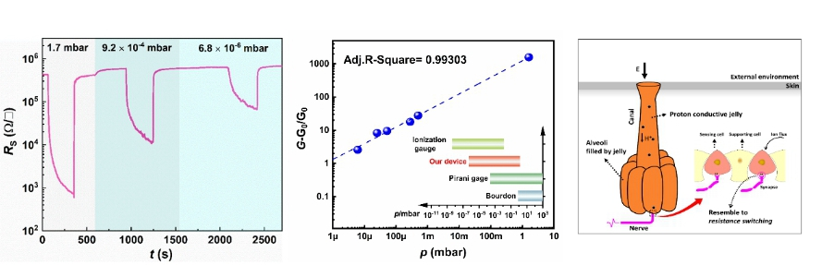
High sensitivity to vacuum (left); Performance test as vacuum gauge (middle); Schematic diagram of Lorentz ampulla (right).
In this study, the weak van der Waals force between the mica and oxide film interface was used to achieve the transfer of centimeter-scale freestanding WO₃ film. This novel transfer technology for large-area oxide films is expected to show great application prospects in the field of flexible electronics and integrated circuits.
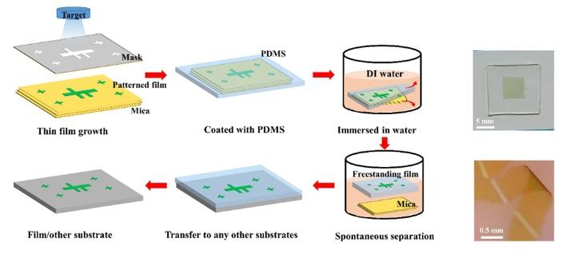
Preparation method of transferrable free-standing films (left) and the obtained centimeter-level free-standing films (right).
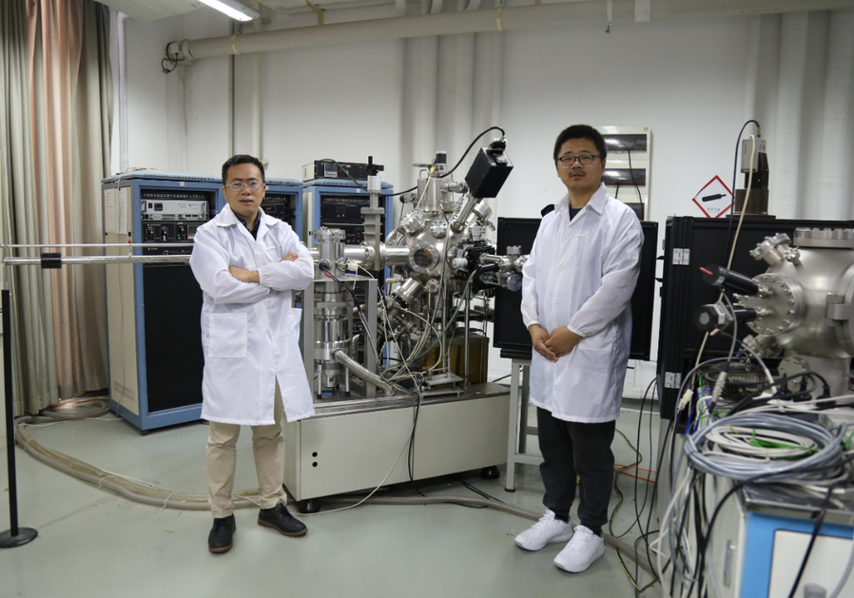
Porf. Ping-Hua Xiang (left) and Dong-Dong Xu (right, the first author), a doctoral candidate.
This work was supported by the National Key Research and Development Program of China, Shanghai Science and Technology Innovation Action Plan, the NSF of China and the ECNU Academic Innovation Promotion Program for Excellent Doctoral Students.
The paper can be acquired in the website: https://onlinelibrary.wiley.com/doi/full/10.1002/adfm.201902497

